***National Conference***

**on**

***Applied Science and Humanities in Engineering, ASHE-2016***

(9th to 10th Sept, 2016)

The National Conference on ***Applied Science and Humanities in Engineering, ASHE-2016***was organised from 9th to 10th Sept, 2016 at Jaipur Engineering College and Research Centre, Jaipur in association with **IEEE Education Society, New Delhi** and **Intellectuals Society for Socio-Techno Welfare, ISST Journal.** The whole Conference was classified into 13 Technical Sessions, related to Physics, Mathematics, Chemistry, English and Humanities. Each session contributed to the main theme of the Conference.

The Conference received an overwhelming response from all over India and received about 356 research papers in all. All the papers were subjected to peer review process and after which 121 papers were shortlisted for presentation in Physics, Mathematics, Chemistry and English & Humanities.

The selected papers in Physics, Mathematics and Chemistry were published in Vol.7 (2016) No. 1 Jan. 2016 / No.2 Jul 2016 issue of:

* **ISST Journal of Applied Physics [ISSN: 0976-903x]**
* **ISST Journal of Mathematics and Computing System [ISSN: 0976-9048]**
* **ISST Journal of Applied Chemistry [ISSN: 0976-7355]**
* **Conference Proceedings, *The New Horizons* [English and Humanities]**

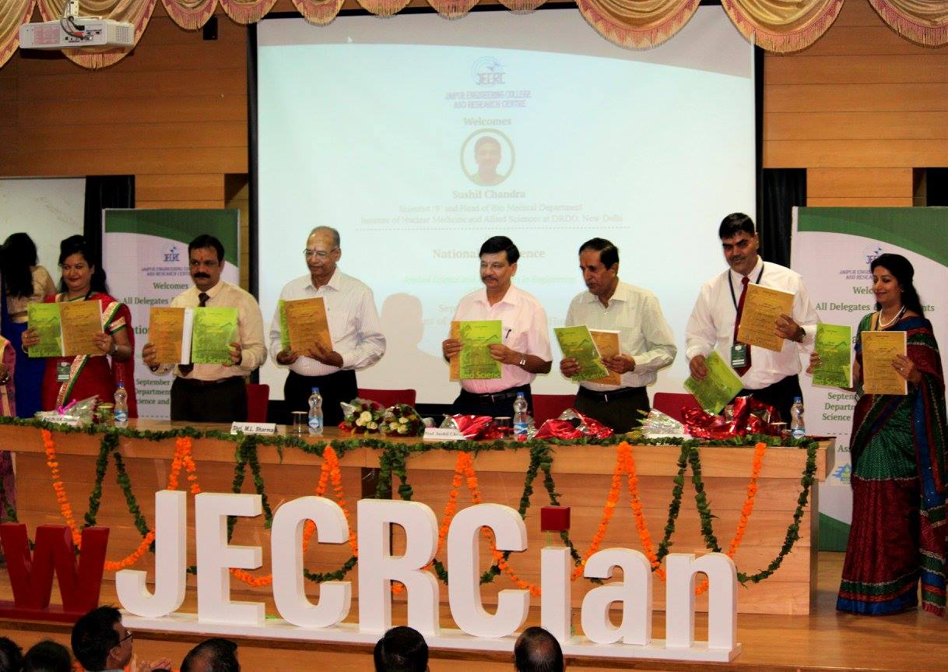

In the Inaugural Session on 9th Sept, the Chief Guests were **Dr. Sushil Chandra,** Scientist 'F' and Head of Bio Medical Department at Institute of Nuclear Medicine and Allied Sciences at DRDO, New Delhi, and **Prof. G.S. Randhawa,** IIT, Roorkee.

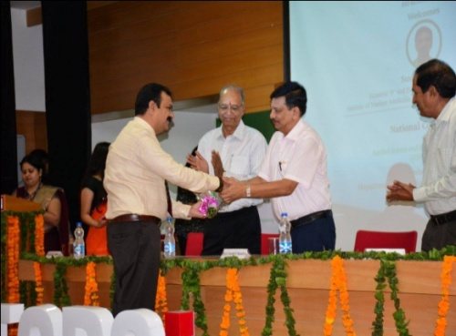 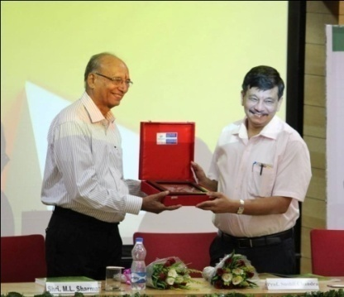

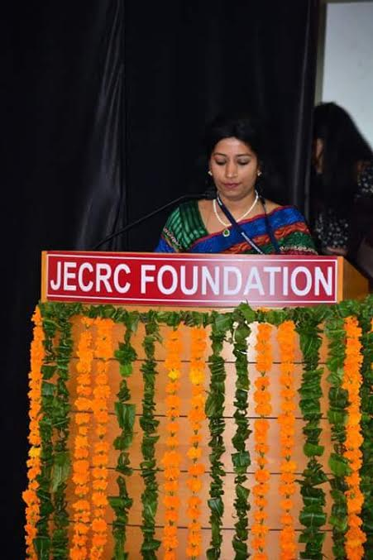 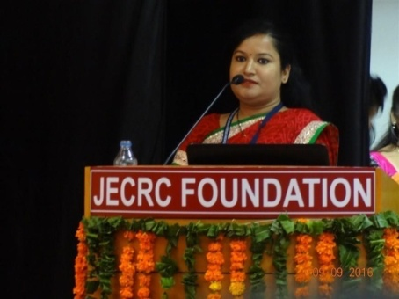 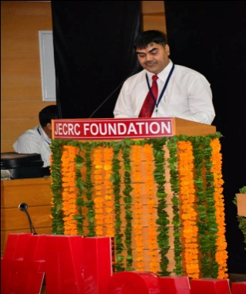

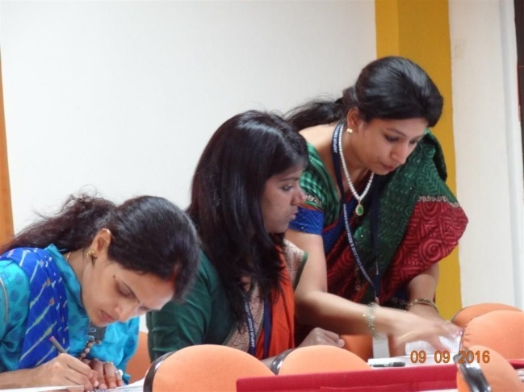 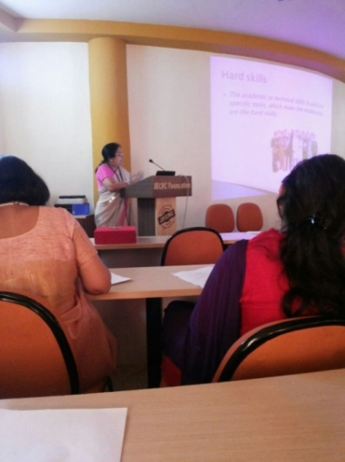 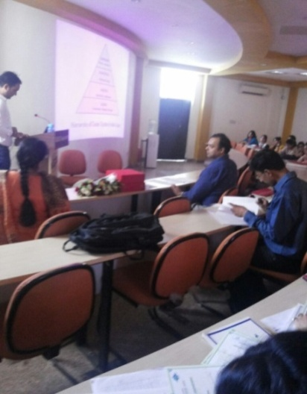

In the Valedictory Session, the Chief Guests were Mr. Michael Cannon from Canada and Mr. Nathan Roach from Japan. In each Department, 4 Best Papers were selected, and first three of them were also presented mementoes as token of remembrance.

 